**Super Admin of Django**

1. **Task Details:**

Create a funcion in views.py which can export the saved data in .csv format and that trigger button should be on superadmin of django long with Actions.

1. **Task Screeenshots:**

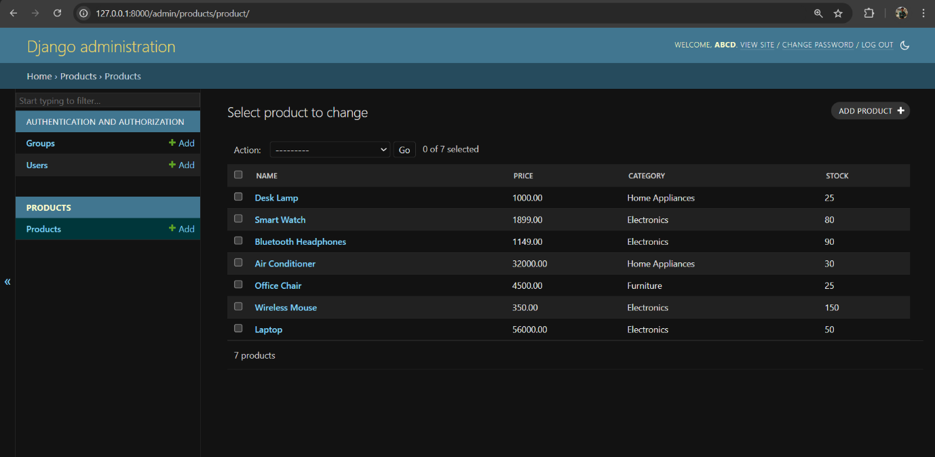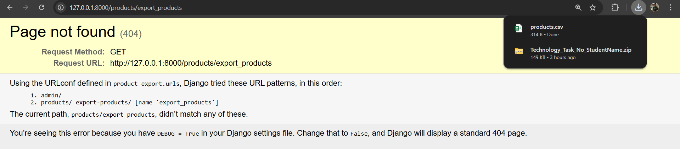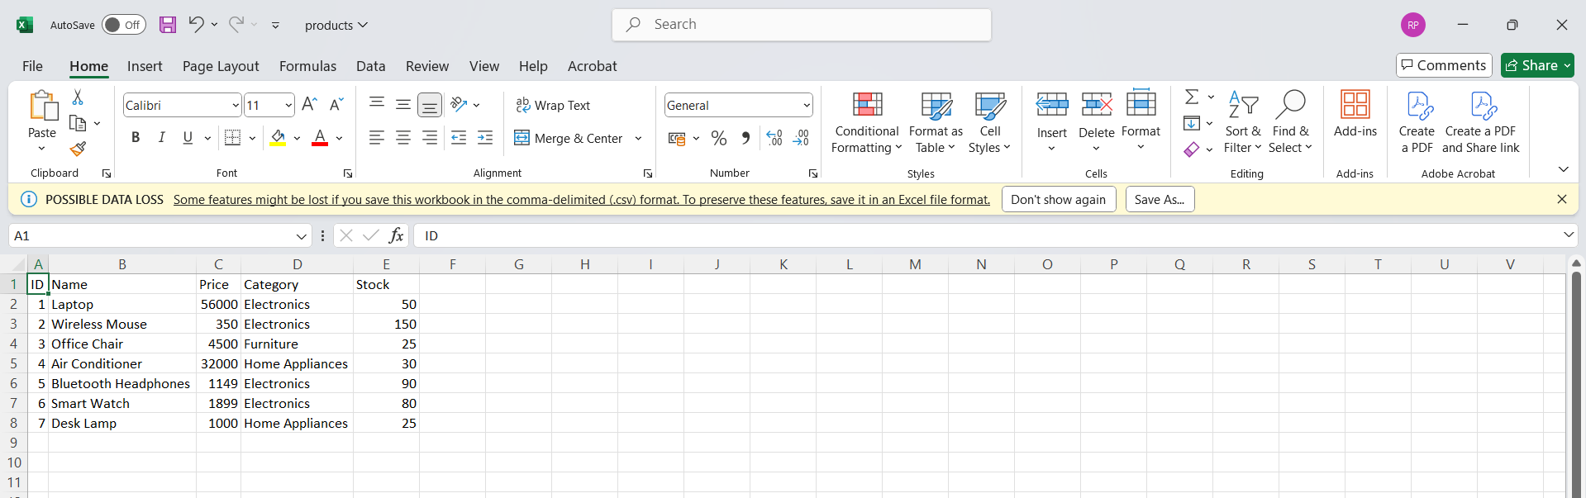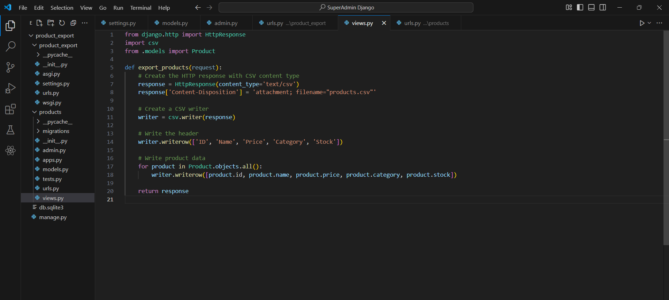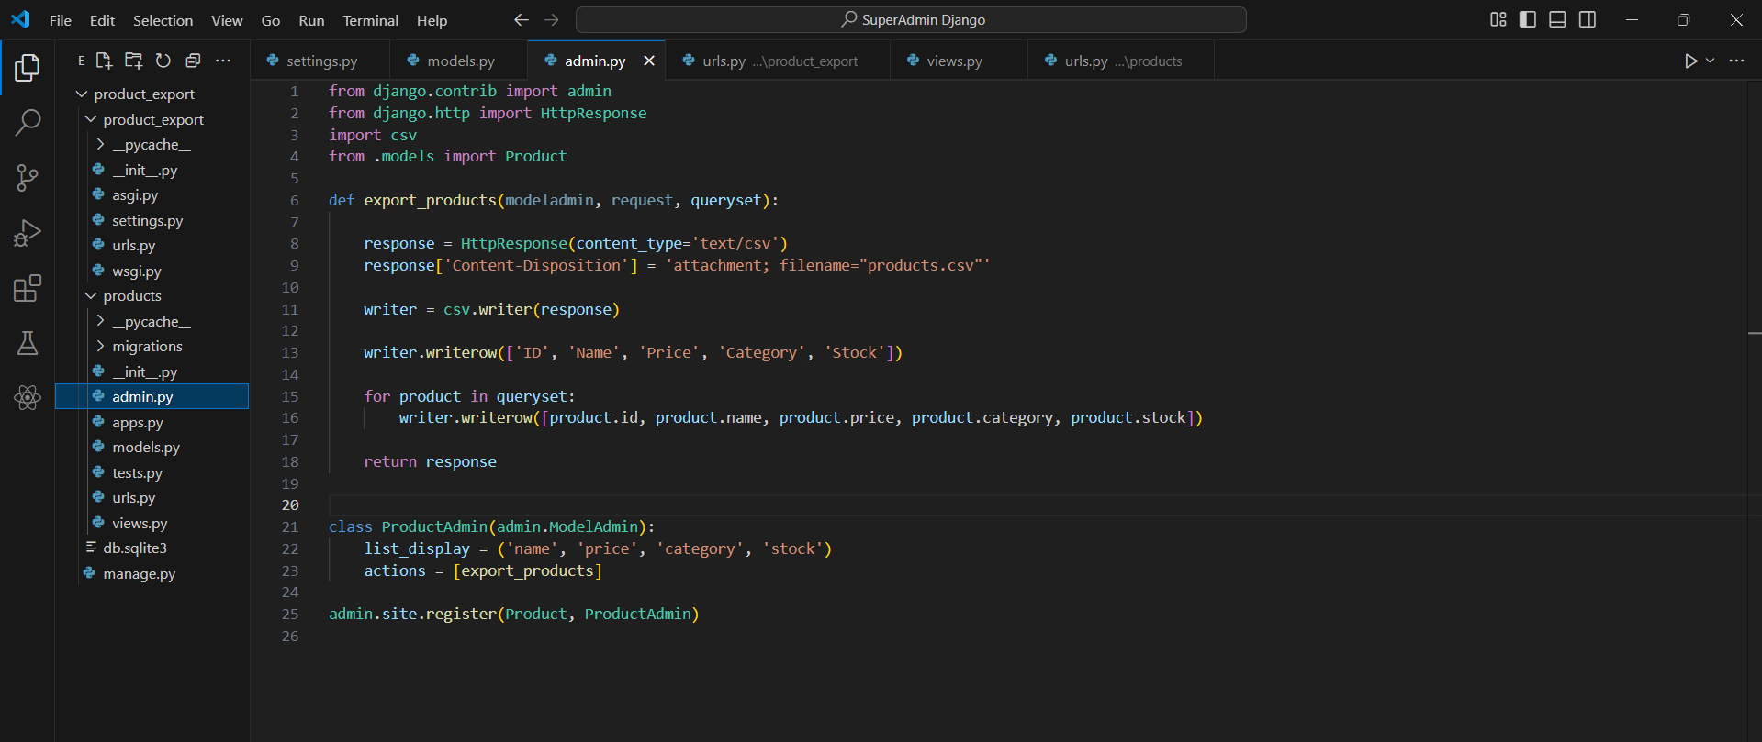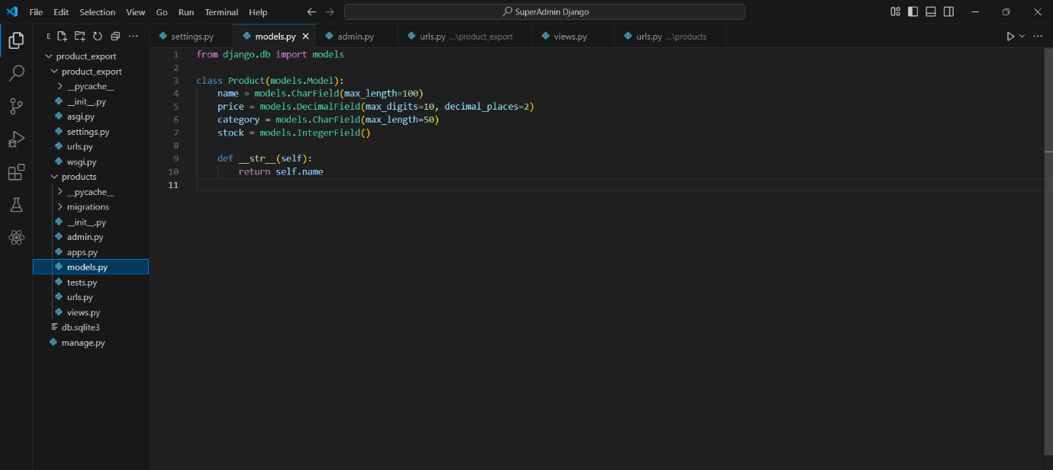

1. **Algorithm used:**

* **Model Setup**: Created a Product model with fields like name, price, category, and stock.
* **Admin Integration**: Registered the Product model in Django Admin and added a custom action to export product data to a CSV file.
* **Export Action**: The export functionality generates a CSV file containing selected product data when triggered from the Admin's "Actions" dropdown.
* **Optional URL**: Optionally, a URL and view can be set up to expose the export functionality outside the Admin interface.